1.1
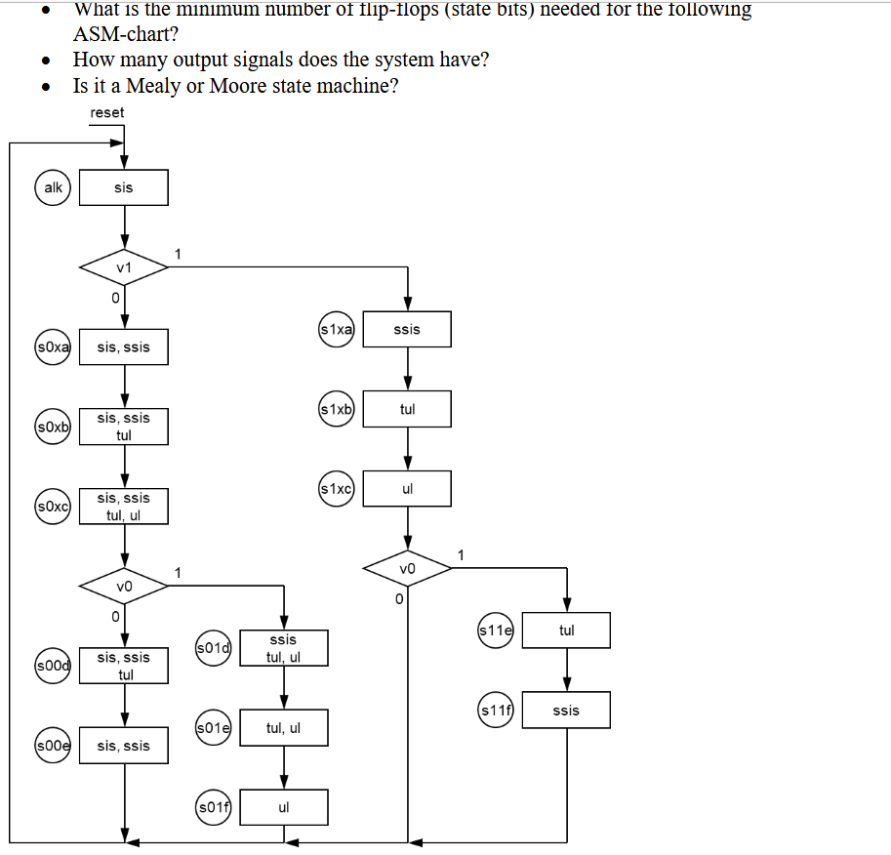
There are 14 states so 4 flip flops are needed, this can be proven via log2(14) if needed.
Outputs are sis, ssis, tul and ul, for a total of 4.
Moore, since there are no states with round corners which would be used to represent a mealy-type state machine.
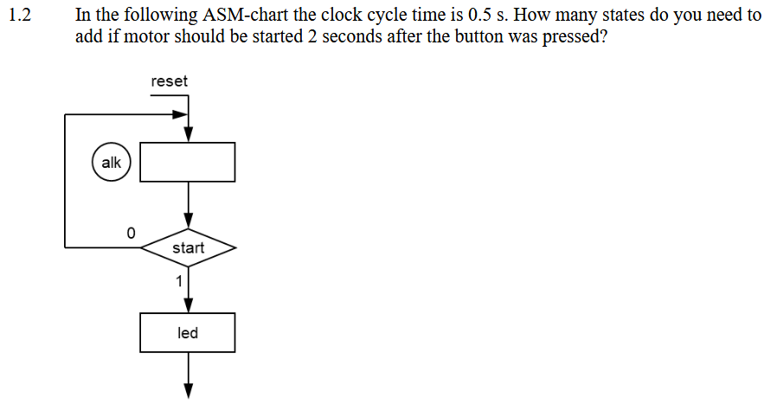
Two states should be added between ‘start’ and the motor (which I assume is started one clock tick after the last depicted state as that bottom arrow implies) so that the expected wait time is ~1,51-2 s depending on when in the clock cycle the button is pressed. If it is imperative that the machine waits at least two seconds. Then a fourth state should be added to the chain to increase the wait time to ~2,01-2,5 s.
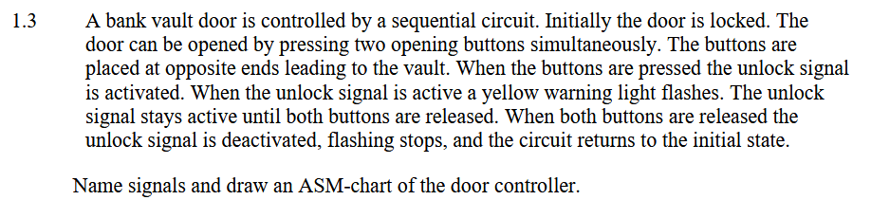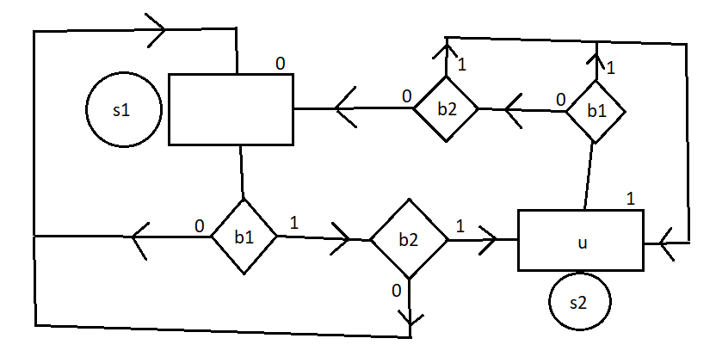
The ‘u’ output is the unlock signal, ‘b1’ is the first button, and ‘b2’ is the second button.

